**Day-3 API Integration Report - [Luxury Furniture Marketplace]**

**STEPS :**

* Made a new project in Santy.io
* Copied the CLI command and pasted it in cmd of the new project I was working on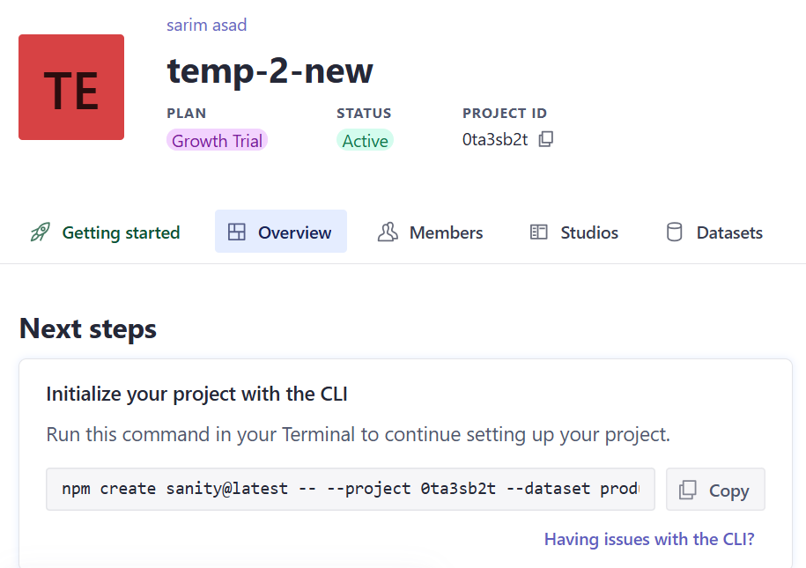
* Went in API section and generated TOKENS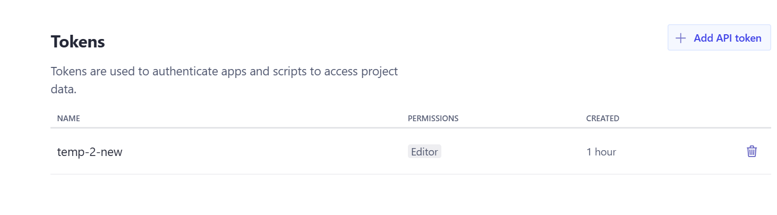
* Pasted tokens in .env.local  
  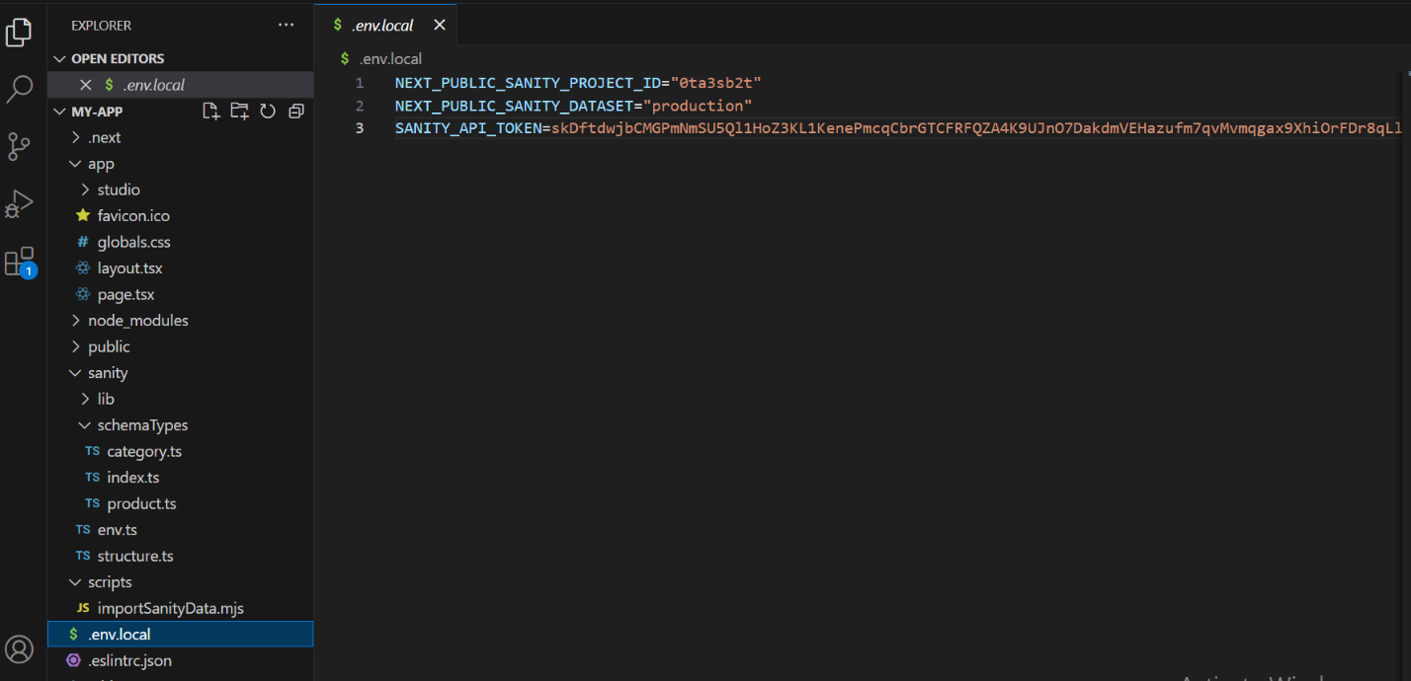
* In /sanity/schemaTypes made files of product.ts and category.ts and pasted their respective content into them.

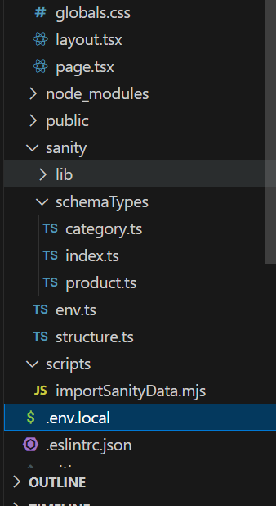

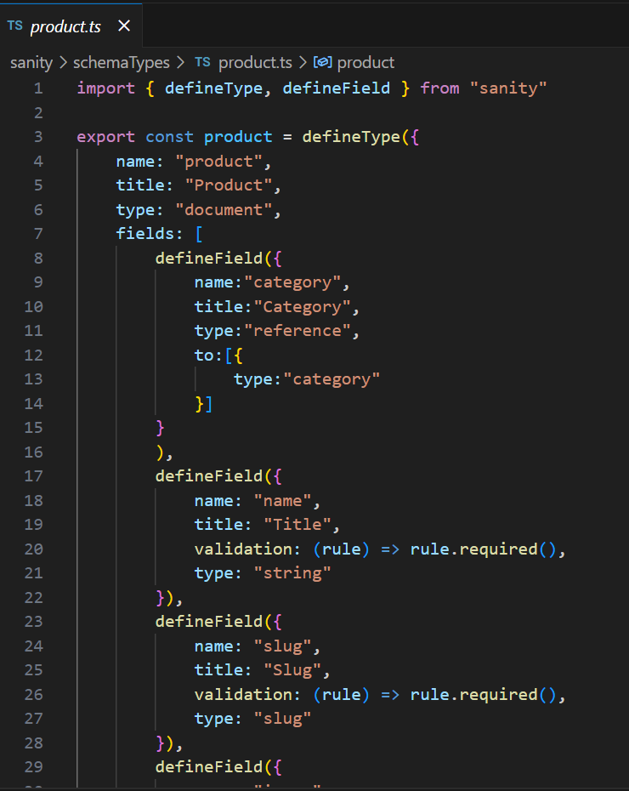

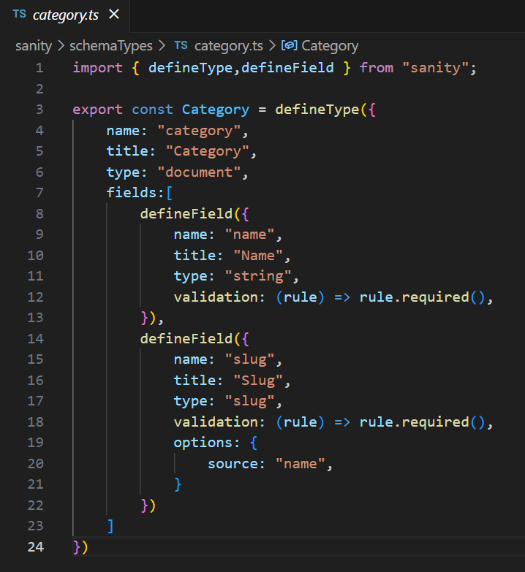

* Imported these files in index.ts  
  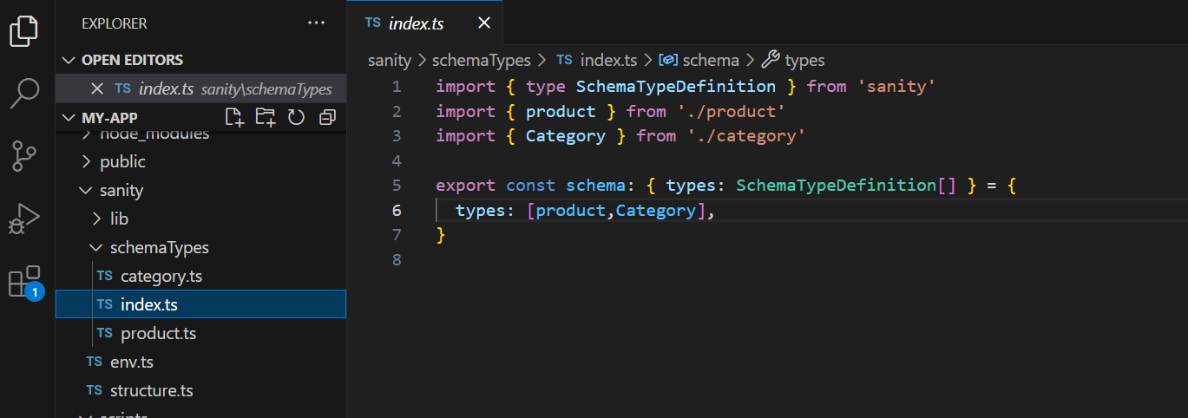
* Made a folder scripts and a file in it, importSanityData.mjs for dara migration

( /scripts/importSanityData.mjs)

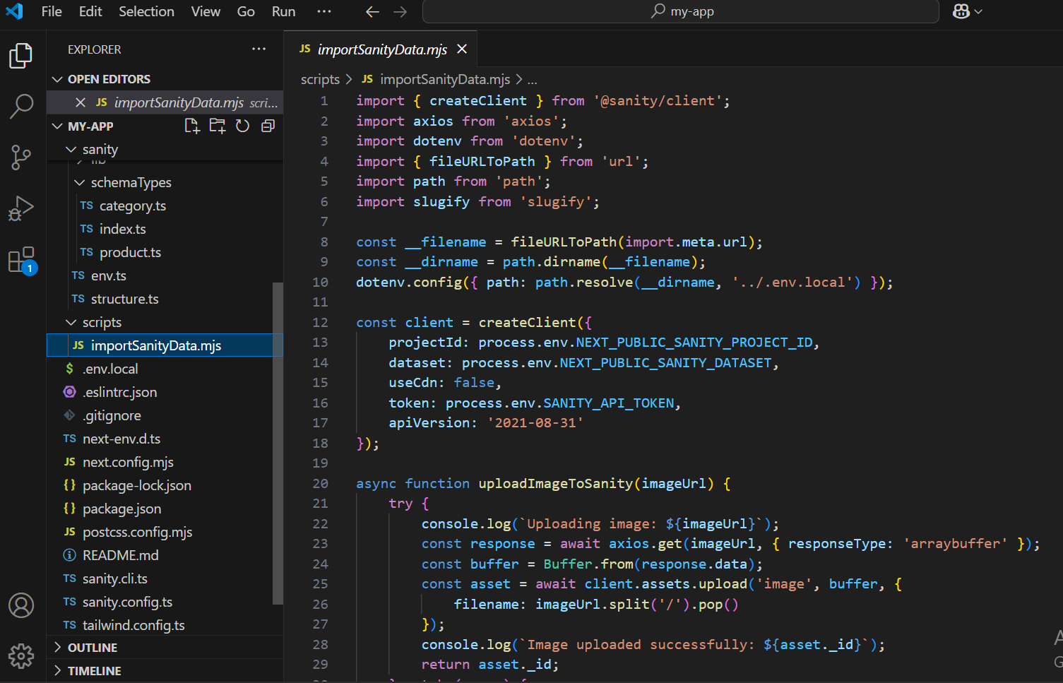

NOTE: I was provides with a .ts and .js file for migration, I tried a lot but faced errors due to which my work also got delayed and this would be submitted late so then I took help of a teacher and made an mjs file for migration (subhan kaladi at yt), ill be working on this later to solve my errors on my own.

* In package.json add command to import data  
  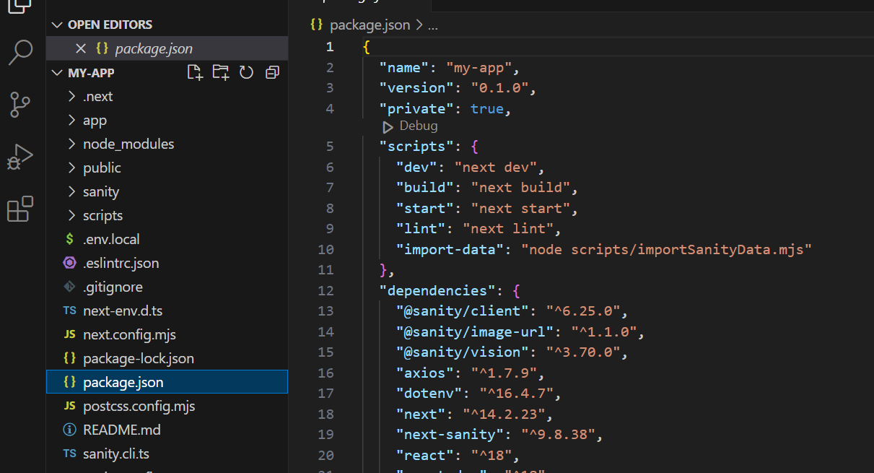
* Run command to install axios dotenv as it gave error ( npm install @sanity/client axios dotenv )
* npm install @sanity/client axios dotenv
* Run command => ( npm run import-data )
* Followed by npm run dev
* Data is imported into the sanity.io after login through email id

